Daily Journal

January 7,2026

Day 1

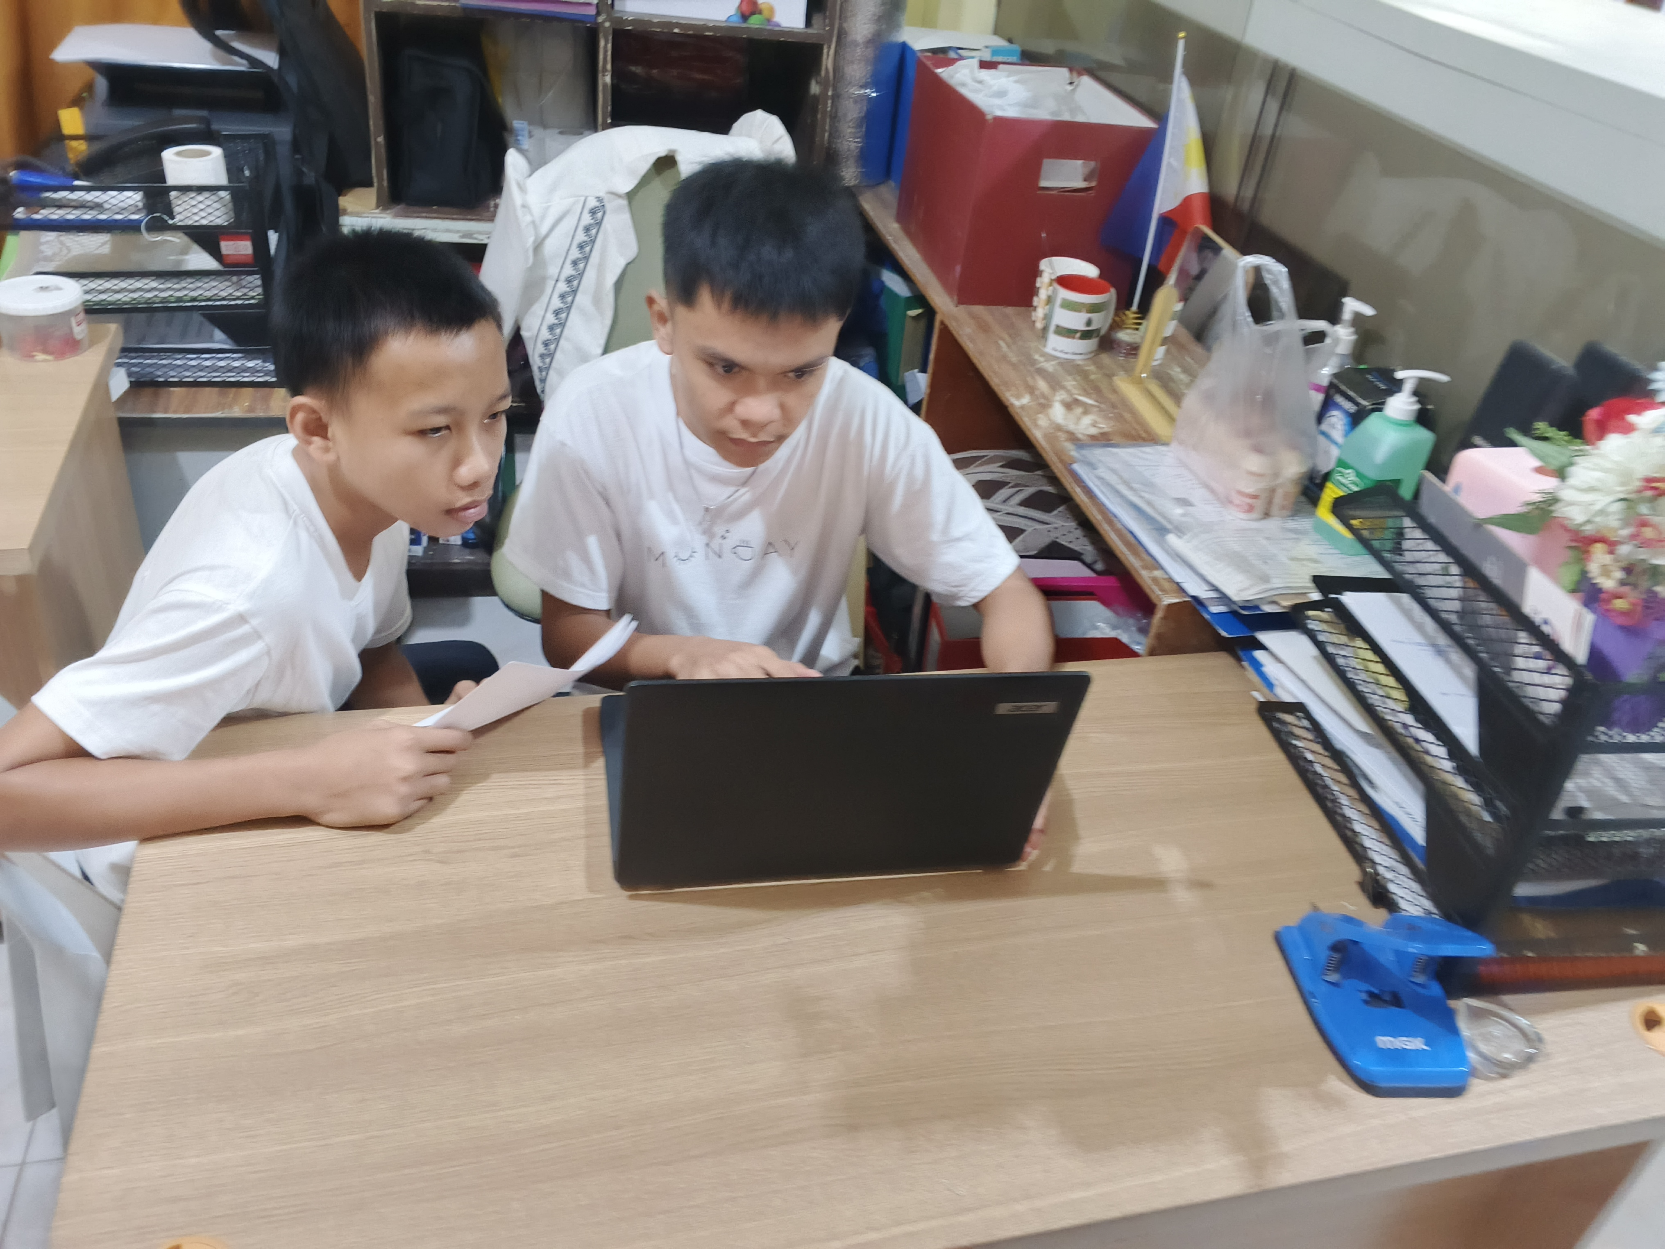

On my first day of immersion I sat alongside a peer at a wooden desk, clutching a sheet of paper while we focused intently on a laptop—I was busy crafting a layout, likely for a local governance-related material (such as a community bulletin, project proposal, or information sheet).

